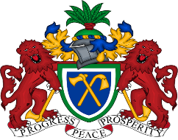
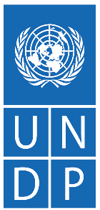

Strengthening National and Municipal Capacities for the Sound Management of PCBs and uPOPs

Annual Progress Report
Country | The Gambia
Project Number: | 01002135
Reporting Period: | 1st January to 31st December 2025
Total Budget: | USD $1,079,486.37 (€999,788.00)
Implementing Partner: | UNDP

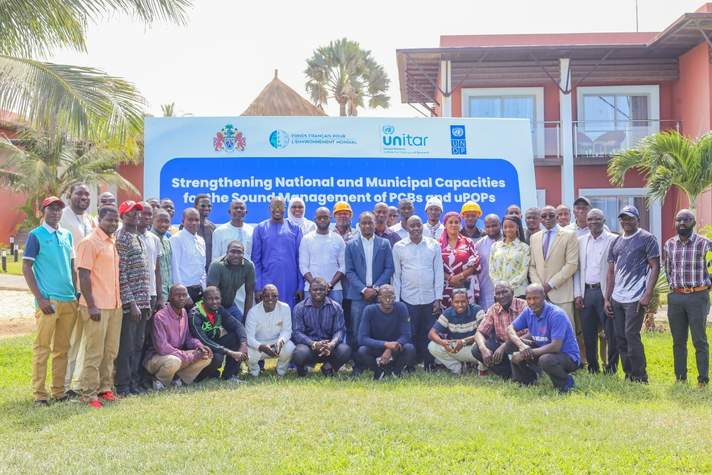
Dec. 2025 UNDP PCB and UPOPs Awareness training with NAWEC, NEA, NDMA and UNITAR, funded by FFEM.

February 2026

ACRONYMS
BEP Best Environmental Practices
BAT Best Available Techniques
CRR Central River Region
ESMP Environmental and Social Management Plan
DIM Direct Implementation Modality
FFEM French Facility for the Global Environment
GEF Global Environment Facility
GRM Grievance Redress Mechanism
KMC Kanifing Municipal Council
LRR Lower River Region
NAWEC National Water and Electricity Company
NDMA National Disaster Management Agency
NEA National Environment Agency
NBR North Bank Region
PCB Polychlorinated Biphenyl
POP Persistent Organic Pollutants
PMU Project Management Unit
SESP Social and Environmental Screening Procedure (SESP)
SDGs Sustainable Development Goals
SME Small and Medium Enterprises
UNDP United Nations Development Programme
UNITAR United Nations Institute for Training and Research
uPOPs Unintentional Persistent Organic Pollutants
URR Upper River Region

Contents
I. EXECUTIVE SUMMARY 4
II. PURPOSE 5
III. PARTNERSHIP & COORDINATION 6
IV. RESULTS 7
V. IMPLEMENTATION CONSTRAINTS AND LESSONS LEARNED 16
VI. FUTURE WORK PLAN 17
VII. FINANCIAL STATUS 20
VIII. EXPRESSION OF THANKS 22
ANNEXES 24
ANNEX 1: HUMAN INTEREST STORIES 24
ANNEX 2: DATA SOURCE 26
ANNEX 3: Table 4: Expenditure across Partner Organisations – Euro version 27

EXECUTIVE SUMMARY
The Gambia, as a party to the Stockholm Convention, has pledged to eliminate the production and use of intentionally produced Persistent Organic Pollutants (POPs), reduce releases from unintentionally produced POPs, and ensure the environmentally sound management of stockpiles and wastes containing POPs. The country, however, faces persistent challenges in managing PCBs and uPOPs, including incomplete inventory data, weak regulatory frameworks and limited technical capacity for safe disposal and uPOPs reduction.

To address these challenges, the United Nations Development Programme (UNDP), and the United Nations Institute for Training and Research (UNITAR), in partnership with the French Facility for Global Environment (FFEM), the National Environmental Agency (NEA), National Water and Electricity Company (NAWEC), and other national and municipal stakeholders, is jointly implementing the project “Strengthening National and Municipal Capacities for the Sound Management of PCBs and uPOPs in The Gambia”. This €999,788.00 (US$1,079,486.37) project, funded by the French Facility for Global Environment (FFEM) and supported by the French Ministry of Ecological Transition and Territorial Cohesion (MTECT) supports The Gambia’s commitments under the Stockholm Convention to eliminate Persistent Organic Pollutants (POPs), manage PCB-contaminated equipment and waste, and reduce unintentional POP (uPOP) emissions – particularly from uncontrolled open waste burning.

During the reporting period, the project has moved into the implementation phase, leveraging resources from the co-financed project titled “Capacity building for PCBs and uPOPs in The Gambia” funded by the Global Environment Facility (GEF). Key interventions undertaken across the project’s major components include:
- Strengthening PCB management and disposal planning through the construction of a temporary storage facility for PCB-contaminated equipment and the engagement of Greenway to support the planning and implementation of the export and environmentally sound disposal of PCB-contaminated waste to Spain.
- Building national and municipal technical capacity on PCB management, uPOP reduction, sustainable waste management, and circular economy approaches.
- Piloting interventions to reduce uPOP emissions, and
- Developing legal and institutional frameworks for sustainable waste management.
From these interventions, the project has already delivered tangible outputs and results, including enhanced institutional readiness for PCB management; improved national and municipal capacity, with a total of 123 stakeholders trained; visible local-level benefits through the construction of compost chambers and the provision of waste bins and tricycles, contributing to reduced open burning and improved solid waste management practices; and strengthened policy foundations to support long-term reduction of uPOP emissions and compliance with the Stockholm Convention.

Despite challenges related to recruitment delays and stakeholder coordination, corrective measures – including streamlined processes and a centralised document system – have been implemented. With the Project Manager and Monitoring & Evaluation Officer now fully on board, and key stakeholders aligned to support implementation, the project is well-positioned for accelerated delivery and stronger results in 2026.

PURPOSE
The Project aims to achieve results that would facilitate the implementation of the Stockholm Convention in The Gambia. This goal is expected to be achieved through the decommissioning and environmentally sound disposal of PCB waste, as well as the reduction in emissions and releases of uPOPs from the uncontrolled open burning of waste. The FFEM project is structured into four components:
- Legal and Administrative Strengthening: Establish and enforce regulations and administrative procedures for PCB management and uPOPs reduction.
- Management of PCBs: Safely manage and dispose of PCB-contaminated equipment and waste and remediate contaminated sites.
- Reduction of uPOPs Emissions: Implement strategies to reduce uPOPs emissions from waste management practices, particularly open burning.
- Monitoring and Outreach: Conduct continuous monitoring, learning, adaptive feedback, and outreach activities to ensure the project's sustainability and effectiveness.
The expected results of the projects include:
- Strengthening of legal frameworks and administrative processes for the sound management of PCBs and the reduction of releases of uPOPs strengthened.
- Environmentally Sound Management of PCBs and PCB-Contaminated Sites.
- Minimisation of uPOP releases from open burning of waste.

The project contributes to both the United Nations Sustainable Development Cooperation Framework (UNDSCF) and the United Nations Development Programme (UNDP) Country Programme Document (CDP), as indicated below:

UNDSDCF Outcome 1.1: By 2028, women, children, displaced people, youths, and persons with disabilities (PWD), particularly in rural and urban disaster-prone and conflict-prone areas, will be resilient to climate-related and other shocks and have access to sustainable food, water, sanitation, and hygiene (WASH), health systems, education, and social protection.
The FFEM project’s expected outcomes contribute to strengthening the resilience of vulnerable populations by reducing their exposure to hazardous chemicals and persistent organic pollutants (POPs). Through strengthened regulatory frameworks, improved institutional coordination, and enhanced operational practices, along with strengthened national and municipal capacities for the sound management of PCBs and uPOPs, the project promotes safer environments that support access to clean water by minimising the risks of chemical leakage, preventing contamination of soil and food systems, and contributing to improved public health outcomes.

CPD Output 1.1.2: Solutions adopted for chemicals and waste management, and to achieve universal access to clean, affordable, and sustainable energy and clean cooking.
The project contributes to CPD Output 1.1.2 by strengthening legal, institutional, and administrative frameworks for safe chemicals and waste management in line with the Stockholm Convention. These actions reduce hazardous exposures, support environmentally sound disposal practices, and promote cleaner, safer waste disposal systems that align with national objectives for reducing pollution and promoting sustainable development.

PARTNERSHIP & COORDINATION
The United Nations Development Programme (UNDP) serves as the implementing and coordinating entity, providing overall project management, quality assurance, and strategic oversight under the Direct Implementation Modality (DIM). UNDP ensures compliance with its financial, procurement, and safeguard standards, while leveraging its global networks for technical support and risk management.
The United Nations Institute for Training and Research (UNITAR) is the technical partner, delivering specialised expertise in chemicals and waste management, capacity-building, and training on Best Available Techniques (BAT) and Best Environmental Practices (BEP). UNITAR also facilitates knowledge exchange and South-South cooperation, drawing on lessons learned from similar projects in Africa and beyond.
National partners play a critical role in implementation and sustainability:
- National Environment Agency (NEA) – National focal point for the Stockholm Convention and lead government partner, responsible for policy coordination, enforcement, and laboratory analysis of PCBs.
- National Water and Electricity Company (NAWEC) – Key stakeholder for PCB management, responsible for inventory, safe handling, and decommissioning of contaminated transformers.
- Kanifing Municipal Council (KMC) and other local councils – Frontline actors for municipal solid waste (MSW) management and uPOPs reduction, including piloting circular economy approaches.
- Ministry of Environment, Climate Change & Natural Resources (MECCNAR) – Provides policy oversight and integration into national development frameworks.
- Ministry of Agriculture – Supports pilots for non-burning alternatives to agricultural biomass management.
Civil society organisations (CSOs), academia, and private sector actors such as WasteAid Gambia, Women Initiative Gambia, Green Up Gambia, Mbolo, among others, are engaged to facilitate on-the-ground implementation, policy integration, and community engagement, including facilitating access to the hardest to reach in society and leveraging local knowledge to enhance decision-making. This promotes inclusive participation, ensuring vulnerable groups (women, youth, and informal waste workers) benefit from project interventions.
This collaborative approach is expected to lead to more effective management of PCBs and uPOPs, protecting human health and the environment.
Coordination Mechanisms
To maximise synergies and avoid duplication, UNDP aligns this FFEM-funded project with the ongoing GEF-funded initiative “Capacity Building for PCBs and uPOPs in The Gambia”. Both projects fall under the UNDP Environment Cluster and operate under the leadership of the Cluster Team Lead. Coordination measures include:
- Meeting with the GEF-project coordinator and former M&E officer to review progress, align activities to avoid duplication, risk identification and mitigation, and resource optimisation.
- Harmonising approaches and activities, for example, the national PCB inventory through UNITAR’s support; disposal planning and execution through the hiring of a specialised company; the construction of a PCB-temporary storage facility, and MSW management through the provision of waste bins and tricycles to councils and health facilities.
  - These activities, specifically, Activity 2.1 Developing a national inventory and database of electrical equipment to identify items containing or contaminated with PCBs; Activity 2.2 Decommissioning and disposing of PCB-containing devices and decontaminating affected equipment; Activity 3.1 Reduction of uPOP emissions through effective MSW treatment systems that avoid open burning, are supported through GEF co-financing to accelerate delivery.
- UNDP and UNITAR hold monthly coordination meetings to review progress, plan upcoming activities, and accelerate implementation where needed.
- Knowledge Sharing – UNDP and UNITAR facilitate cross-learning and alignment between the project and other national and regional initiatives.

This structured, multi-stakeholder approach ensures policy coherence, resource efficiency, and sustainability, and enhances project impact.

RESULTS
The FFEM project has moved beyond preparatory activities and entered full implementation, achieving notable progress across its four components. Coordination with the GEF-funded initiative has been instrumental in accelerating this transition and realising various milestones. Next, key activities undertaken and progress achieved are presented, structured around the project’s main components.
COMPONENT 1: Strengthening of legal frameworks and administrative processes for the sound management of PCBs and the reduction of releases of uPOPs.
Expected Output: National legal, regulatory, and administrative frameworks strengthened for the sound management of PCBs and the reduction of uPOPs releases in The Gambia.
Progress:
- Legal and Regulatory Frameworks
Significant progress has been made toward strengthening the national legal and regulatory framework for PCB and uPOPs management:
- A Draft PCB/uPOPs regulation for regulating the lifecycle of PCBs and uPOPs in The Gambia has been developed. This draft is currently under review by a project-hired expert/consultant and will subsequently be shared with stakeholders for review, validation, and adoption.
- Apart from the activity above, a detailed review and harmonisation of existing environmental regulations is ongoing to ensure full alignment with the national environmental protection priorities as well as the country’s obligations under the Stockholm Convention, particularly in relation to PCB phase-out, uPOPs release reduction, and waste management.
- Policy Instruments and Enforcement Mechanisms
Key policy and strategic instruments have been updated and/or finalised. These include the Environmental Quality Monitoring and Enforcement Strategy, the national five-year Communication Strategy for the promotion of safe management and handling of PCBs and uPOPs (2023–2027), the PCB Management Plan, and the ban on plastic bag orders. Collectively, these instruments are expected to strengthen the national policy framework and enhance the enforceability of PCB and uPOPs management measures.

- Institutional Capacity Building
Capacity-building interventions have substantially strengthened technical and institutional capacities across relevant sectors:
- Fifty (50) engineers and technicians were trained on PCB identification and labelling, safe handling and interim storage procedures, and compliance with national PCB control requirements. In addition to this, in December 2025, an additional fifty-six (56) institutional staff were trained (8 females, 48 males) from the National Water and Electricity Company (NAWEC), the National Environment Agency (NEA), and the National Disaster Management Agency (NDMA) on PCB/uPOPs awareness, regulatory compliance, and risk reduction. Additionally, sixty-seven (67) municipal solid waste (MSW) actors were enrolled in a structured, long-term capacity-building programme launched in November 2025. This programme integrates an initial in-person workshop with a series of follow-up webinars, thematic questionnaires, continuous peer-to-peer engagement through a dedicated WhatsApp platform, and a complementary online course. Together, these components are designed to support sustained improvements in operational capacity and promote the adoption of sound waste management practices that reduce uPOPs generation.
- A targeted national awareness-raising campaign was organised in Q2 2025 to improve understanding of PCB legislation and responsibilities. A multi-sectoral engagement was achieved, with participation from key Ministries, Departments, and Agencies (MDAs), resulting in improved role clarity. It is expected that this will enhance compliance with PCB management obligations.
All three activities under this component – Activity 1.1: Strengthening of legal framework and administrative processes for the sound management of PCBs; Activity 1.2: Strengthening the capacity of national and local authorities to take action to reduce uPOP releases through better MSW management; and Activity 1.3: Improvement in the financial viability of solid waste management systems and waste management actors – are currently under implementation, with consultants already onboard and actively executing the respective assignments.
COMPONENT 2: Environmentally sound management of PCBs and PCB-contaminated sites.
Expected Output: PCB-contaminated equipment safely stored and prepared for disposal in compliance with international standards.

Progress:
- PCB Inventory
- Comprehensive PCB inventory covering PCB-containing and PCB-contaminated equipment, completed. A consultant has been hired by the project to facilitate the updating and validation of the PCB inventory covering PCB-containing and PCB-contaminated equipment.
- A centralised digital PCB database was established to systematically record, update, and manage inventory data, ensuring tracking of PCB stocks throughout their lifecycle, planning and prioritisation for their safe storage and disposal, as well as monitoring of progress toward the elimination targets. This provides a critical evidence base for decision-making and compliance reporting under the Stockholm Convention.

- Infrastructure:
Substantial progress has been achieved in establishing the physical infrastructure required for environmentally sound PCB management. Procurement was finalised for the construction of the Brikama PCB storage facility, designed to meet international standards for hazardous waste temporary storage. The work is currently 90% completed, with commissioning anticipated following final inspections.
This intervention, along with a disposal contract with Greenway (the consultancy firm hired to support this activity), ensures that approximately 75 tonnes of PCB-contaminated equipment identified through the national inventory is securely stored and fully prepared for export and final disposal.
- Risk Assessment of PCB Contaminated Sites
Preliminary Risk Assessments of PCB-contaminated sites were conducted by Greenway in May and July 2025 at priority locations identified through the national PCB inventory developed under the GEF-funded project. These assessments examined the condition and integrity of PCB-containing equipment, evaluated potential environmental release and exposure pathways, and identified associated risks to human health and the surrounding environment. The results enabled risk-based prioritisation of sites for secure storage, transport, and disposal. This directly contributes to the delivery of Activity 2.3 - Risk assessment of PCB contaminated sites – under Component 2 of the FFEM project.
Despite this progress, it must be acknowledged that Activity 2.1: Capacity building to maintain an up-to-date national inventory and assist in the management of contaminated sites – is yet to start due to some challenges (see subsection on Implementation Constraints, and Lessons Learned).
COMPONENT 3: Minimising releases of uPOPs from open burning of waste.
Expected Output: Municipal solid waste management practices improved through BAT/BEP pilots.
Progress:
Pilot interventions targeting BAT/BEP in municipal solid waste management have been successfully implemented (see Annex 1), demonstrating practical alternatives to open burning and uncontrolled disposal. Under the initiative:
- Five compost chambers are established in women-led horticultural gardens across four regions (NBR, CRR, LRR, and URR).
- Six hundred and fifty (650) waste bins distributed to support source separation and proper disposal at the community level.
- An additional seven hundred (700) waste bins distributed to the Kanifing Municipal Council (KMC) to strengthen the national anti-littering programme.
- Ten (10) tricycles provided to healthcare facilities to improve safe waste handling and reduce unsafe burning of medical and general waste.
- Five (5) motorbikes supplied to enhance waste management monitoring and enforcement.
- Fencing completed at Jarra Soma and Janjanbureh disposal sites, reducing uncontrolled access, open dumping, and open burning activities.
At this stage of implementation, the FFEM project is focused on strengthening the systemic and institutional foundations for sustainable MSW management. Under the initiative;
- An ongoing consultancy is supporting the development of an MSW strategy, integrating BAT/BEP principles, circular economy approaches, and National policy and institutional frameworks.
- Sixty-seven (67) waste sector actors completed their first session of the 9-month training on Municipal solid waste management, circular economy, and operational good practices to minimise environmental and health risks.
Collectively, these interventions have strengthened waste containment systems, lowered the potential for uPOPs generation in targeted locations, and enhanced technical capacity, professionalisation, and the long-term sustainability of municipal solid waste management operations.
COMPONENT 4: Monitoring, learning, adaptive feedback, outreach and awareness raising, and evaluation
Expected Output: Awareness raised and knowledge management systems strengthened.
Progress:
Significant progress has been made in establishing functional systems for knowledge management, monitoring, and adaptive learning:
- Under the FFEM initiative, a centralised knowledge management system has been established and is operational, enabling systematic storage, retrieval, and sharing of project documentation, lessons learned, and technical outputs.
- Safeguards instruments, such as the Gender Action Plan, Grievance Redress Mechanism, and Communication Strategy, have been developed to ensure environmental and social risk considerations are integrated into implementation, monitoring, and reporting processes.
- These systems support adaptive feedback loops, facilitating evidence-based adjustments and institutional learning throughout project implementation.
- The project website has been developed to enhance outreach, visibility and public access to key project information. This could be accessed using the link below:
https://storymaps.arcgis.com/stories/83542052b8914f1e80e59479d621b5b8

Table 1: Progress by Project Components
Component | Output | Activity | Status | Remarks
Component 1:  Strengthening of legal frameworks and administrative processes for the sound management of PCBs and the reduction of uPOP releases | National legal and administrative frameworks revised, and institutional capacity strengthened for PCB/uPOPs management; enhanced capacity of national and local authorities to reduce uPOP releases via improved municipal solid waste (MSW) management; improved financial viability of solid waste management systems and waste management actors; and targeted technical assistance to support effective implementation and compliance. | 1.1 Strengthen the legal framework and administrative processes for the sound management of PCBs. | ☐ Not yet started  ☒ In progress  ☐ Completed (indicate month & year)  ☐ Cancelled  ☐ Delayed | The development of a PCB/uPOPs Regulation was initiated by the GEF initiative. This FFEM project is continuing with the efforts made by the GEF initiative. Specifically, a consultant has been hired by the FFEM project to facilitate the finalisation of the draft regulation produced by the GEF initiative. Efforts will also focus on aligning this draft regulation with the parent legislation, the Hazardous Chemicals and Pesticides Management and Control Act. This harmonisation process aims to ensure consistency across the regulatory framework by aligning procedural requirements, clarifying institutional responsibilities, and standardising penalties.
 |  | 1.2 Strengthen the capacity of national and local authorities to take action to reduce uPOP releases through better MSW management. | ☐ Not yet started  ☒ In progress  ☐ Completed (indicate month & year)  ☐ Cancelled  ☐ Delayed | The FFEM Project has engaged a consultant to support the strengthening of municipal solid waste (MSW) management systems and enhance the capacity of national and local authorities to reduce uPOP releases through improved waste handling, collection, and disposal practices. During an initial mission to The Gambia, the consultant conducted extensive stakeholder consultations using mixed methods, systematically identified critical gaps in the municipal solid waste management system, and developed a targeted action plan outlining the legal reforms and regulatory measures required to enable sustainable and integrated MSW management. This intervention is designed to advance best practices in MSW, promote compliance with environmental standards, and contribute to long-term pollution reduction efforts.
 |  | 1.3 Improve the financial viability of solid waste management systems and waste management actors. | ☐ Not yet started  ☒ In progress  ☐ Completed (indicate month & year)  ☐ Cancelled  ☐ Delayed | A consultant has been engaged to strengthen the financial viability and sustainability of waste management systems by assessing existing cost structures, identifying revenue-generation opportunities, and proposing mechanisms that enhance financial performance across relevant stakeholders. Through a first field mission to The Gambia, the consultant has engaged a wide range of public and private sector actors to obtain baseline information for the activity. This work aims to support municipalities, service providers, and regulatory authorities in adopting economically sound waste management models that can sustain operations, improve service delivery, and contribute to long-term reductions in uPOP releases.  The consultancy is expected to provide practical financial and institutional recommendations that will help ensure waste management services remain efficient, affordable, and resilient.
 |  | 1.4 Technical Assistance | ☐ Not yet started  ☒ In progress  ☐ Completed (indicate month & year)  ☐ Cancelled  ☐ Delayed | In collaboration with UNITAR, targeted technical assistance is being provided to strengthen institutional capacities and enhance stakeholder compliance. This support aims to equip relevant authorities with the tools, guidance, and operational know-how needed to enforce standards, improve monitoring, and ensure sustained reductions in uPOP releases.
Component 2:  Environmentally Sound Management of PCBs and PCB Contaminated Sites | PCB-containing and PCB-contaminated electrical equipment identified and recorded in a national inventory and database; decommissioning, decontamination, and disposal arrangements for PCB-containing equipment initiated; risk assessments of PCB-contaminated sites conducted; and international technical support mobilised to ensure compliance with international standards. | 2.1 Development of a national inventory and database of electrical equipment to identify items containing or contaminated with PCBs | ☐ Not yet started  ☒ In progress  ☐ Completed (indicate month & year)  ☐ Cancelled  ☐ Delayed | The inventory of PCBs has been completed. This process identified PCB-contaminated equipment—primarily transformers—requiring international disposal (see progress under Activity 2.2).  Construction of the Brikama storage facility is at an advanced stage, with 90% completion achieved, providing a secure interim solution for hazardous waste containment.
 |  | 2.2 Decommissioning and disposal of devices containing PCBs, decontamination of devices contaminated with PCBs | ☐ Not yet started  ☒ In progress  ☐ Completed (indicate month & year)  ☐ Cancelled  ☒ Delayed | With resources from the GEF, a contract has been signed with Greenway to ensure environmentally sound management of identified stockpiles. This contract covers the export of PCB-contaminated equipment for environmentally sound disposal. Disposal activities were originally scheduled for 2025 but have been postponed to 2026 as a result of delays associated with procurement processes and administrative clearances.
 |  | 2.3 PCB Contaminated Site Risk Assessment | ☐ Not yet started  ☒ In progress  ☐ Completed (indicate month & year)  ☐ Cancelled  ☐ Delayed | Preliminary Risk Assessments of PCB-contaminated sites were completed by Greenway in May and July 2025 at priority locations identified through the national PCB inventory. The assessments evaluated equipment integrity, environmental exposure pathways, and associated health and environmental risks, enabling risk-based prioritisation of sites for secure storage, transport, and disposal. This directly advances the implementation of Activity 2.3 under Component 2 of the FFEM Project.
 |  | 2.4 International Technical Support | ☐ Not yet started  ☒ In progress  ☐ Completed (indicate month & year)  ☐ Cancelled  ☐ Delayed | International technical expertise has been mobilised to guide and strengthen the quality of risk assessments and to ensure alignment with global best practices for PCB management. This includes experts from UNITAR, UNDP and Greenway.
Component 3:  Minimising releases of uPOPs from open burning of waste | UPOP emissions being reduced through improved MSW treatment systems that avoid open burning; capacities of non-governmental actors strengthened to divert or manage waste that would otherwise be burned; pilot activities demonstrating POPs reduction through non-combustion disposal alternatives based on the 3Rs conducted; non-burning alternatives for agricultural residual biomass promoted; and international technical support mobilised to ensure compliance with best practices and environmental standards. | 3.1 Reduce uPOP emissions through effective MSW treatment systems that avoid open burning: | ☐ Not yet started  ☒ In progress  ☐ Completed (indicate month & year)  ☐ Cancelled  ☐ Delayed | Key pilot interventions promoting BAT/BEP for municipal solid waste management were completed, including the establishment of five compost chambers in women-led horticultural gardens, distribution of 650 waste bins and 10 tricycles to healthcare facilities, and fencing of the Jarra Soma and Janjanbureh disposal sites to enhance waste containment. Additional anti-littering support was provided through the distribution of 700 waste bins and five motorbikes to KMC. Under the FFEM component, work is ongoing to develop a comprehensive MSW management strategy integrating BAT/BEP and circular economy principles.
 |  | 3.2 Reduce emissions of persistent organic pollutants by strengthening the roles and capacities of non-governmental actors that reduce or divert waste that would otherwise be burned | ☐ Not yet started  ☒ In progress  ☐ Completed (indicate month & year)  ☐ Cancelled  ☐ Delayed | Through collaboration with UNITAR, the capacities of non-governmental waste actors have been strengthened to enhance waste diversion and prevent open burning. A total of 67 waste actors received training on municipal solid waste management and circular economy practices, equipping them with practical skills to improve segregation, recycling, and community-level waste handling. These efforts directly contribute to reducing uPOP emissions by empowering frontline actors who play a critical role in diverting waste from uncontrolled burning.
 |  | 3.3 Demonstration of POPs reduction through pilot activities of non-combustion solid waste disposal alternatives based on the 3Rs | ☐ Not yet started  ☒ In progress  ☐ Completed (indicate month & year)  ☐ Cancelled  ☐ Delayed | Pilot actions demonstrating non-combustion solid waste disposal alternatives, based on the 3Rs (reduce, reuse, recycle), have been initiated to support POPs reduction. In addition to the composting initiative, the GEF-funded project distributed waste bins and tricycles, further improving waste segregation and collection.
 |  | 3.4 Reduce uPOP releases from agriculture by promoting non-burning alternatives for residual biomass management | ☐ Not yet started  ☒ In progress  ☐ Completed (indicate month & year)  ☐ Cancelled  ☐ Delayed | Efforts to reduce uPOP releases from agriculture have been supported through the promotion of non-burning alternatives for managing residual biomass. Building on the GEF project’s broader 3R and BAT/BEP approaches, farmers across NBR, CRR, URR, and LRR have been sensitised on sustainable practices such as composting and improved organic waste utilisation, helping to divert agricultural residues away from open burning. These interventions contribute to reducing uPOP emissions while improving soil health and supporting climate-smart agricultural practices.
 |  | 3.5 International Technical Support | ☐ Not yet started  ☒ In progress  ☐ Completed (indicate month & year)  ☐ Cancelled  ☐ Delayed | International technical support has been mobilised to ensure that project interventions align with established best practices and environmental standards.
Component 4:  Monitoring, Outreach and Knowledge Management. | Awareness of PCB phase-out enhanced among key stakeholders; public awareness raised on reducing POPs releases from open-air combustion of solid waste; farmers sensitised on non-burning alternatives to reduce uPOP releases from agricultural biomass combustion; impacts of uPOP reduction efforts assessed; and project monitoring and evaluation activities implemented. | 4.1 Awareness of PCB phase-out | ☐ Not yet started  ☒ In progress  ☐ Completed (indicate month & year)  ☐ Cancelled  ☐ Delayed | Targeted awareness and training activities were conducted to strengthen national understanding of PCB phase-out obligations and hazardous chemicals management. In addition, in December 2025, fifty-six (56) staff from NAWEC, NEA, and NDMA received training on PCB/uPOPs awareness, regulatory compliance, and risk reduction. Collectively, these efforts enhanced institutional capacity and stakeholder awareness of PCB risks and safe management practices.
Component 4:  Monitoring, Outreach and Knowledge Management. |  | 4.2 Raising awareness of the reduction of POPs releases from the open-air combustion of solid waste | ☐ Not yet started  ☒ In progress  ☐ Completed (indicate month & year)  ☐ Cancelled  ☐ Delayed | Training sessions were delivered to Area Councils, healthcare facilities, and other local actors to promote safer waste handling practices, adoption of BAT/BEP principles, and alternatives to open burning. These activities have enhanced community-level awareness and supported behavioural changes essential for reducing uPOP emissions.
Component 4:  Monitoring, Outreach and Knowledge Management. |  | 4.3 Educate farmers on the need to reduce uPOP releases from agricultural biomass combustion | ☐ Not yet started  ☒ In progress  ☐ Completed (indicate month & year)  ☐ Cancelled  ☐ Delayed | Awareness efforts under the project have supported the promotion of safer agricultural practices by educating farmers on the risks of open biomass burning and its contribution to uPOP emissions.
Component 4:  Monitoring, Outreach and Knowledge Management. |  | 4.4 Assess the impact of efforts to reduce uPOP releases | ☐ Not yet started  ☒ In progress  ☐ Completed (indicate month & year)  ☐ Cancelled  ☐ Delayed | Joint monitoring and assessment activities have been initiated to evaluate the effectiveness of GEF interventions aimed at reducing uPOP releases across the waste and agriculture sectors. Baseline data collection is underway under the FFEM project to support future impact measurement. These efforts will inform evidence-based adjustments to improve the effectiveness of uPOP reduction strategies.
Component 4:  Monitoring, Outreach and Knowledge Management. |  | 4.5 Project monitoring and evaluation | ☐ Not yet started  ☒ In progress  ☐ Completed (indicate month & year)  ☐ Cancelled  ☐ Delayed | Project monitoring and evaluation activities have continued to guide implementation, ensure synergies with the GEF initiative and alignment with project objectives. Under the FFEM project, key safeguards and governance tools, including an M&E plan, Gender Action Plan, Communication Strategy, and ESMP, Grievance Redress Mechanism, were developed and are pending validation. A centralised document management system was also established to strengthen reporting, data management, and institutional coordination.

IMPLEMENTATION CONSTRAINTS AND LESSONS LEARNED
Several implementation challenges continue to affect project efficiency and delivery timelines. Among these are coordination difficulties across a diverse set of international and local stakeholders, compounded by inconsistent representation and scheduling conflicts. Additionally, delays in recruiting key Project Management Unit (PMU) personnel and consultants, budget misalignments, and poor knowledge management have slowed progress on critical activities.

  - Delayed Recruitment of Key Staff
The late onboarding of the PMU significantly slowed project execution. This hindered timely planning, activity rollout and effective collaboration among stakeholders. The Moniroting and Evaluation Officer and the Project Coordinator/Manager were onboarded in the second and third quarters of 2025 respectively. Efforts are still underway to hire the Finance and Administrative Officer. Similarly, the recruitment process for qualified consultants was delayed due to lengthy internal evaluation processes and a limited pool of qualified candidates.

  - Coordination Challenges Among Stakeholders
Project implementation faced persistent coordination challenges due to the involvement of multiple international and local partners, including UNITAR, the GEF-funded project team, and national stakeholders. Aligning schedules for Technical Committee (TC) and Project Steering Committee (PSC) meetings proved difficult, with frequent scheduling conflicts and limited availability of representatives. Moreover, inconsistent representation and frequent personnel substitutions from partner institutions disrupted continuity, weakening institutional memory and slowing decision-making. New representatives often lacked context on prior discussions and agreed action points, requiring additional time for orientation and reducing efficiency in advancing project objectives.
Similarly, harmonising activities with the GEF initiative’s PMU required extensive consultations to avoid duplication and to ensure strategic alignment, which added complexity to work planning and reporting.

  - Budget Alignment challenges
Another implementation challenge stemmed from the absence of documented budget notes and rationale from the project design phase. The team that developed the project seem to have left insufficient documentation explaining key budgetary assumptions and decisions. As the current PMU members joined after project approval, they lacked critical context on how and why certain budget allocations were made. This resulted in significant time being spent reviewing, consulting widely with partners, and holding multiple meetings to reconstruct the underlying justifications and determine where adjustments were necessary. These efforts were essential to rationalise the budget, finalise Annual Work Plans, secure the required approvals, and ensure full compliance with UNDP policies before further expenditures could proceed.

LESSONS LEARNED
- Alternative communication platforms are essential to complement formal channels, as demonstrated by the effective use of WhatsApp groups to maintain stakeholder engagement. The project experienced delays in information flow when relying solely on formal communication pathways, particularly when convening PSC and TC meetings. Introducing alternative platforms, such as dedicated WhatsApp groups and periodic virtual check-ins and meetings, proved effective in ensuring timely updates and maintaining engagement across dispersed stakeholders. This demonstrated the need for flexible, multi-channel communication systems to avoid bottlenecks.
- Early and consistent stakeholder coordination mechanisms are critical. Stakeholder representation (personnel) changed several times during the project, leading to fragmented engagement and repeated orientation. Where coordination mechanisms are formalised early, and agreed consultation schedules are established in good time, activities progress more efficiently. This highlighted the need for upfront and continuous coordination structures to maintain coherence despite institutional personnel changes.
- Comprehensive documentation and centralised knowledge management are vital. The project encountered instances where institutional memory was lost due to staff turnover or responsibility shifts. This affected continuity in key processes such as PMU onboarding. Implementing a centralised document system significantly improved efficiency, reduced duplication of effort, and ensured that critical information was accessible to all team members. This justified the need for consistent documentation practices across the project lifecycle.
- Flexible implementation arrangements help bridge temporary capacity gaps. Lengthy recruitment processes resulted in operational delays and gaps in technical delivery. Temporary consultants and short-term support staff proved instrumental in sustaining momentum while long-term positions were being finalised. This demonstrated that flexibility in staffing arrangements is essential for maintaining progress during periods of institutional transition.
- Timelines must remain realistic and adaptive. Several activities required scheduling adjustments due to procurement delays and unforeseen operational constraints. Periodic reassessment of timelines allowed the project to remain realistic without compromising quality. This reinforced that adaptive management, supported by regular progress reviews, is necessary to align work plans with actual implementation conditions.

FUTURE WORK PLAN
In collaboration with national implementing partners, the UNDP and UNITAR planned the following key activities:
- Ensure sound disposal of PCB-contaminated materials.
The project will prioritise advancing the environmentally sound disposal of PCB-contaminated equipment by strengthening coordination with Greenway and national partners. Following the signing of the disposal contract, the project team, together with UNITAR, has requested a detailed operational work plan from Greenway covering timelines, technical specifications, and logistical arrangements for the export and final treatment of PCB waste from The Gambia. The team will review the plan, agree on the next operational steps, and begin preparatory actions for safe transport, treatment, and export in accordance with international standards.
- Completion of the following activities:
  - The review of existing MSW management policies, strategic plans, regulatory frameworks, institutional mandates, and operational procedures to help identify gaps and opportunities for alignment with Best Environmental Practices (BEP) and Best Available Techniques (BAT), in accordance with the Stockholm Convention.
  - The review of the existing Legal Framework for Administrative Processes for the sound management of PCBs. The consultancy seeks to align existing national legal frameworks with current environmental realities and international obligations under the Stockholm Convention, particularly those relating to the sound management of PCBs.
  - The assessment and enhancement of Financial Mechanisms for SWM in The Gambia. The consultancy will conduct a comprehensive assessment of the current financial mechanisms supporting Solid Waste Management (SWM) systems and actors in The Gambia, identify gaps and opportunities for improvement, conduct an economic valuation of proposed financing options, and design a financially viable model aligned with international best practices.
  - The Baseline Assessment consultancy will generate essential baseline data on current pollution levels, existing legal and regulatory frameworks, and institutional capacities at both local and national levels. It will also document community practices, knowledge, and attitudes regarding the management of PCBs and unintentional POPs (uPOPs). The findings will serve as a foundation for refining project activities and establishing reference conditions for measuring future progress and evaluating project impacts.
- Collaborate with NAWEC and NEA to conduct awareness campaigns on PCBs and open waste burning through community radios.
- Conduct a midterm project review.
- Organise joint training workshops and awareness events in collaboration with UNITAR, NAWEC, Municipal Councils and NEA.
- Implementation of pilot waste management initiatives with NEA, KMC and Mbolo.
- Enhance stakeholder coordination and communication strategies.
- Extend outreach activities beyond KMC to rural communities.

Table 2: Annual workplan for 2026
PLANNED ACTIVITY RESULTS | ACTIVITY | Q1 | Q2 | Q3 | Q4 | RESPONSIBLE PARTY
Activity Result 1.1: Legal framework and admin processes strengthened for PCBs Management. | Activity 1.1: Strengthening of legal framework and administrative processes for the sound management of PCBs. |  |  |  |  | UNDP
 | Activity 1.2: Strengthening the capacity of national and local authorities to take action to reduce uPOP releases through better MSW management. |  |  |  |  | UNDP
 | Activity 1.3: Improve the financial viability of solid waste management systems and waste management actors. |  |  |  |  | UNDP
Activity Result 2. PCBs and PCB-contaminated sites environmentally and soundly managed. | Activity 2.1: Capacity building to maintain an up-to-date national inventory and assist in the management of contaminated sites. |  |  |  |  | UNDP
 |  |  |  |  |  | UNITAR
 | Activity 2.2: Decommissioning and disposal of devices containing PCBs, decontamination of devices contaminated with PCBs. |  |  |  |  | UNDP
 |  |  |  |  |  | UNITAR
 | Activity 2.3: Risk assessment of PCB-contaminated sites. |  |  |  |  | UNDP
 | Activity 2.3: Risk assessment of PCB-contaminated sites. |  |  |  |  | UNITAR
Activity Results 3: Minimise uPOP releases from open burning of waste. | Activity 3.1: Reduction of uPOP emissions through effective MSW treatment systems that avoid open burning. |  |  |  |  | UNDP
 |  |  |  |  |  | UNITAR
 | Activity 3.2: Reduction in emission of persistent organic pollutants by strengthening the roles and capacities of non-governmental actors that reduce or divert waste that would otherwise be burned. |  |  |  |  | UNDP
 |  |  |  |  |  | UNITAR
 | Activity 3.3: Demonstration of POPs reduction through pilot activities of non-combustion solid waste disposal alternatives based on the 3Rs. |  |  |  |  | UNDP
 | Activity 3.4: Reduction of uPOP releases from agriculture by promoting non-burning alternatives for residual biomass management. |  |  |  |  | UNDP
Activity Result 4: Information and awareness raising, monitoring and evaluation, learning and evolving feedback strengthened. | Activity 4.1: Awareness raising on PCB phase-out. |  |  |  |  | UNDP
 | Activity 4.1: Awareness raising on PCB phase-out. |  |  |  |  | UNITAR
 | Activity 4.2: Awareness creation on the reduction of POPs releases from the open-air combustion of solid waste. |  |  |  |  | UNDP
 |  |  |  |  |  | UNITAR
 | Activity 4.3: Education of farmers on the need to reduce uPOP releases from agricultural biomass combustion. |  |  |  |  | UNDP
 |  |  |  |  |  | UNITAR
 | Activity 4.4: Assessment of the impact of efforts to reduce uPOP releases. |  |  |  |  | UNDP
 |  |  |  |  |  | UNITAR
 | Activity 4.5: Project monitoring and evaluation. |  |  |  |  | UNDP
Project Management |  |  |  |  |  | UNDP

FINANCIAL STATUS
The total committed donor contribution for the project is €999,788.00 (USD1,079,486.37). As of 31st December 2025, a cumulative total of USD 432,964.48 has been received from the French Facility for Global Environment (FFEM), in line with the signed funding agreement. Based on the donor commitment, the outstanding balance yet to be disbursed amounts to USD 646,521.89, which will be received in subsequent tranches, upon liquidating 80% of the first tranche.

During the reporting period (January–December 2025), project implementation commenced, and an expenditure amounting to $139,864.22 was incurred. These expenses relate primarily to:
- Staff and other personnel costs: $18,097.25
- Contractual services: $75,863.33
- Travel: $24,765.14
- General operating and other direct costs: $10,724.46
- Programme support/implementation costs: $10,414.04
Total cumulative expenditure from FFEM resources thus stands at $139,864.22, leaving an unspent balance of $293,100.26 from funds received to date. In addition, commitments amounting to $56,802.00 have been recorded under general operating and direct costs but have not yet been liquidated as of the reporting date. The Combined Delivery Report (CDR) for the project further notes outstanding advances to UN Agencies of $26,526.17, including amounts transferred to UNITAR that are yet to be liquidated.

In addition to FFEM resources, the project continues to benefit from support provided by various national and international partners in both cash and in-kind forms. Contributions include technical support, staff time, provision of facilities, and complementary funding. For instance, the UNDP contributed through technical advisory services and support for consultancy work related to MSW management and policy alignment, as well as the training of 67 waste actors on MSW Management and the circular economy. UNITAR provided additional specialised training and technical assistance as part of its co-financing commitments. National partners, such as the NEA, NAWEC, and KMC, offered staff time, logistical support, and involvement in technical activities. These contributions significantly enhanced project execution capacity and reduced operational delays.

The project also leveraged parallel financing from the GEF-funded PCB/uPOPs initiative, which supported critical complementary activities, including the completion of the national PCB inventory, contracting for PCB disposal, the near-completion of the PCB temporary storage facility and implementation of BAT/BEP demonstration pilots across priority sectors. These combined resources strengthened project delivery and contributed to improving national systems for hazardous chemicals and waste management.
Information in Table 4 shows that, overall, the project has incurred a total of $11,383,350.77 expenditure (including co-financing from partners). The co-financing mobilised to date demonstrates strong interest and collaboration among national and international partners, reinforcing the project’s progress and enhancing its sustainability prospects.

Table 4: Expenditure across Partner Organisations – see Annex 3 for the Euro conversion
ACTIVITIES | FFEM | UNDP | GEF | NEA | NAWEC | KMC | UNITAR | TOTAL Per Component ($)
1 Legal frameworks | 108,888.75 | 34,965.00 | 140,660.28 | 1,719,803.82 | 0 | 209,930.50 | 59,654.01 | 2,273,902.36
2 Environmental and social management of PCBs | 0 | 5,313.18 | 899,821.91 | 1,882,996.88 | 735,000.00 | 0 | 0 | 3523131.97
3 Minimise uPOPs | 6,672.62 | 0 | 636,072.16 | 822,241.99 | 0 | 1,730,188.65 | 0 | 3,195,175.42
4 Awareness | 15,358.62 | 0 | 95,985.25 | 1,223,947.98 | 0 | 359,880.85 | 60,345.99 | 1,755,518.69
Project management (5%) | 8,944.48 | 208.18 | 225,460.38 | 401,009.29 |  |  |  | 635,622.33
UN Levy (1%)
Agency (8%)
Total | 139,864.22 | 40,486.36 | 1,998,000 | 6,050,000 | 735,000.00 | 2,300,000 | 120,000 | 11,383,350.77

EXPRESSION OF THANKS
We express our sincere appreciation to the FFEM for their invaluable support, not only for their generous funding but also for their active collaboration in shaping project activities. Their engagement in decision-making and their responsiveness has been instrumental in ensuring the smooth completion of key tasks, such as the preparation of the procurement plan, towards the initiation of the project. This partnership reflects a shared commitment to sustainable development and impactful environmental action.

We also extend our heartfelt gratitude to all partners and stakeholders contributing to the successful advancement of the project. Particularly, we acknowledge MTECT for its strategic support, as well as UNITAR for its expertise and cooperation, which have significantly strengthened the project’s institutional and capacity-building foundations.

Special recognition is accorded to national and local partners, notably the NEA, NAWEC, and the Kanifing Municipal Council (KMC), whose commitment, collaboration, and leadership remain central to the project’s success. Their active participation has been vital in advancing national and municipal efforts to improve the sound management of Persistent Organic Pollutants (POPs), in line with the objectives and obligations of the Stockholm Convention.

Through this collective partnership, meaningful progress is being made toward safeguarding human health and the environment from the risks associated with PCBs and unintentional POPs. We sincerely value the dedication, cooperation, and shared commitment of all partners and look forward to continued collaboration and impactful results as the project moves into its full implementation phase.

ANNEXES

ANNEX 1: HUMAN INTEREST STORIES
As part of UNDP’s results monitoring and quality assurance framework, the FFEM-funded project PMU joined a field mission in November 2025 across five regions: NBR, CRR, URR, LRR, and WCR to verify key GEF intervention outputs, capture success stories, and identify challenges in interventions implemented through National Implementing Partners. Key focus for the team was on composting sites established under GEF-supported pilots, which promote Best Available Techniques (BAT) and Best Environmental Practices (BEP) to reduce unintentional POPs (uPOPs) emissions from open burning.

Additionally, the FFEM project intensified awareness-raising efforts on PCB risks, focusing on the environmental and public-health impacts of PCB leaks, improper handling, and contamination.

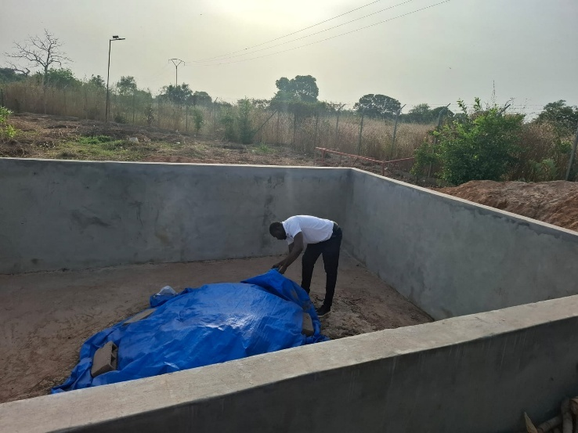
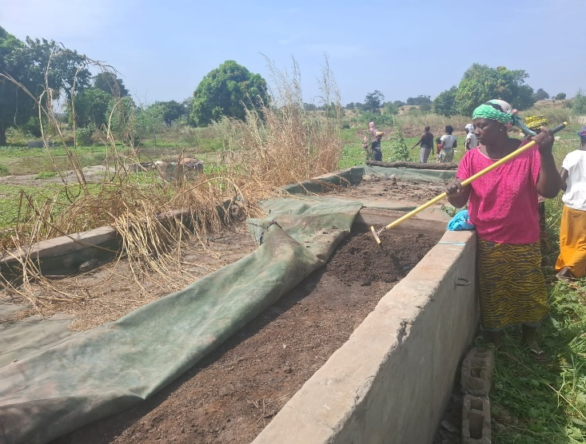
    - Empowering Women Through Composting: Turning Waste into Wealth

Women garden in Farafenni, NBR Kuwonku Ba women garden, URR

In Kuwonku Ba, Upper River Region, women farmers once faced a harsh reality: declining soil fertility and soaring costs of chemical fertilisers. “We used to burn waste because we didn’t know any better,” recalls Ndey Demba, a local farmer. “It polluted the air and left our gardens barren.” Today, thanks to the UNDP-supported uPOPs project under the GEF initiative, Ndey and her peers have become champions of climate-smart agriculture through composting.

As part of the project’s pilot activities, five compost chambers were established in women-led horticultural gardens across four regions - NBR, CRR, LRR, and URR. Ndey’s group in Kuwonku Ba is among the beneficiaries, using chambers that transform organic waste into nutrient-rich fertiliser. The impact has been remarkable. “Our vegetables are greener, yields have doubled, and they weigh more – fetching better prices and improving our health and livelihood,” Ndey says proudly. Jalamang Touray, the Village Development Committee Chairman, adds: “Compost improves soil structure and water retention while reducing reliance on costly chemical inputs; thanks to this initiative, my village is greener and healthier.”

The benefits of compost go beyond agriculture. In Farafenni, North Bank Region, women gardeners report increased income from the surplus they produce and sell in local markets. “We now earn enough to cover household needs and pay school fees,” says Fatou Sillah, another beneficiary.

However, the journeys have not been without challenges. Composting is labour-intensive, and chambers sometimes flood during the rainy season, as reported in both URR and NBR. Despite these hurdles, the women remain resilient. “We work together as a team, with support from men,” Ndey explains. The project also introduced training sessions on Best Available Techniques (BAT) and Best Environmental Practices (BEP), equipping women with knowledge to manage composting efficiently and avoid open burning, a major source of harmful uPOPs emissions. These efforts reduce greenhouse gas emissions, improve soil health, and create cleaner communities.

Looking ahead, women across intervention sites aspire to scale up composting, improve composting structures and explore value-added products like organic fertilisers for sale. Some intervention sites, like MbolletBa in NBR, have requested refresher training to strengthen composting techniques. This initiative under the GEF project demonstrates how simple, locally adapted solutions can deliver multiple wins, including empowering women, improving food security, boosting incomes, and reducing pollution.

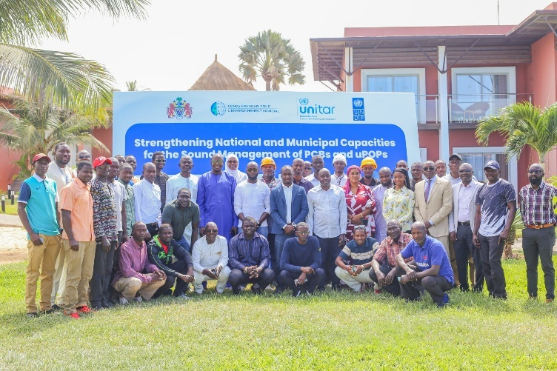
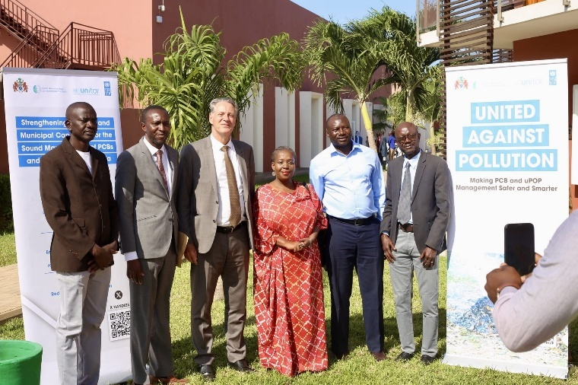
    - Building Awareness on PCB Risks – Dec. 2025
For decades, ageing transformers potentially containing Polychlorinated Biphenyls (PCBs) silently posed a threat to public health and the environment in The Gambia. Classified as Persistent Organic Pollutants (POPs), these chemicals are notorious for their toxicity and long-term persistence. “We knew very little about the risks. Many of us grew up playing very close to these transformers or interacted with them daily because of our roles,” admits Abubakar Darbo, Senior Human Resources Development Manager at NAWEC.
That changed in December 2025, when a landmark awareness training under the FFEM-funded project brought together 56 participants from NAWEC, NEA, and NDMA. Organised by UNDP in partnership with NEA and UNITAR, the two-day capacity-building session introduced participants to PCB identification, associated health and environmental risks, and safe handling practices. The training combined technical presentations with practical exercises on interim storage, labelling, and safety protocols, while reinforcing compliance with the Stockholm Convention. Importantly, NEA representatives served as local trainers, guided by UNITAR, demonstrating a train-the-trainers model that strengthens national ownership and supports future replication of PCB management practices across institutions.
The sessions addressed misconceptions and built confidence among staff to safely manage PCB-contaminated equipment. For Mr Darbo and his colleagues, the training was a wake-up call. “We now understand the risks and the safety protocols’, he reflects. Beyond technical skills, the initiative fostered inter-agency collaboration, ensuring a unified approach to managing hazardous waste. What was once an unknown threat is now a shared responsibility, proof that awareness is the first step toward safety and sustainability.
The NAWEC Legal Unit, represented by the Legal Compliance Officer, Momodou Manneh, highlighted that ‘the training was highly insightful, engaging, and informative, particularly in relation to legal and regulatory compliance’. He explained that the sessions brought clarity to several critical gaps and operational risks associated with PCB management. These insights have since prompted NAWEC to begin drafting its first-ever Policy on the Management of PCBs, which is now under development.
The training also exposed NAWEC to relevant international conventions, including the Basel and Stockholm Conventions on Persistent Organic Pollutants, as domesticated under national law. Accordingly, and in line with its legal mandate to ensure compliance, the NAWEC Legal Unit has updated its compliance matrix to incorporate the following:
a. Hazardous Chemicals and Pesticide Control and Management Act 1994
b. Hazardous Chemicals Regulations, 1999.
c. Hazardous Chemicals and Pesticides (Persistent Organic Pollutants Protection) Regulation 2004.
Accordingly, the absence of a national regulation on Persistent Organic Pollutants (POPs) was highlighted by Mr Manneh as a long-standing gap. The National Environment Agency (NEA), with its relevant partners, was therefore urged to expedite the development and enactment of the relevant regulation.

ANNEX 2: DATA SOURCE
    - Capacity for Polychlorinated biphenyls (PCBs) and Unintentional Persistent Organic Pollutants (UPOPs) in The Gambia Terminal Evaluation report.
    - Strengthening National and Municipal Capacities for the Sound Management of PCBs and uPOPs 2025 Quarterly Reports.
    - Strengthening National and Municipal Capacities for the Sound Management of PCBs and uPOPs 2025 Quarterly Verification Reports.
    - Strengthening national and municipal capacities for the sound management of PCBs and uPOPs in The Gambia, UNITAR 3rd Interim Narrative Report – 30/12/2025

ANNEX 3: Table 4: Expenditure across Partner Organisations – Euro version
ACTIVITIES | FFEM | UNDP | GEF | NEA | NAWEC | KMC | UNITAR | TOTAL Per Component
1 Legal frameworks | 99,850.98 | 32,062.91 | 128,985.48 | 1,577,060.10 | 0.00 | 192,506.27 | 54,702.73 | 2,085,168.46
2 Environmental and social management of PCBs | 0 | 4,872.19 | 825,136.69 | 1,726,708.14 | 673,995.00 | 0.00 | 0 | 3,230,712.02
3 Minimise uPOPs | 6,118.79 | 0.00 | 583,278.17 | 753,995.90 | 0 | 1,586,582.99 | 0 | 2,929,975.86
4 Awareness | 14,083.85 | 0.00 | 88,018.47 | 1,122,360.30 | 0 | 330,010.74 | 55,337.27 | 1,609,810.64
Project management (5%) | 8,202.09 | 190.90 | 206,747.17 | 367,725.52 | 0 | 0 | 0 | 582,865.68
UN Levy (1%)
Agency (8%)
Total | 128,255.49 | 37,125.99 | 1,832,166.00 | 5,547,850.00 | 673,995.00 | 2,109,100.00 | 110,040.00 | 10,438,532.66

DIM is a project implementation approach where UNDP itself directly manages and implements the project, rather than delegating implementation to a national institution.

